Let’s talk about the war

Рабочий лист

Онлайн-экскурсии по музею: https://victorymuseum.ru/excursions/online/; https://victorymuseum.ru/newvtour/GLAV.html

Фамилия, Имя ____________________________________________________________________

Схема движения группы:

Зал Полководцев (The Hall of Commanders) – Зал Памяти и Скорби (The Hall of Memory and Sorrow) – Зал Исторической Правды (The Hall of Historical Truth) – Диорама «Курская битва» (The “Battle of Kursk” Diorama).

Зал Полководцев (The Hall of Commanders)

№ 1. The Hall of Commanders displays busts of military leaders (sculpted by Zurab Tsereteli) and their biographies.
Read the marshals' biographies and match the headings with the names of the commanders. One heading is extra. Complete the table.

1. He graduated from a military school and academy and commanded the Leningrad Front.
2. He took part in the liberation of Prague and received the Hero of a Foreign Country award.
3. He graduated from a military school and successfully fought against Japan.
4. He took part in WWI and WWII and commanded the Victory Parade in 1945.
5. He took part in many wars and was decorated with three Orders of Victory.
6. He received the Hero of the USSR award four times.
7. He was responsible for providing military advice to a foreign country.

Zhukov Georgi Konstantinovich  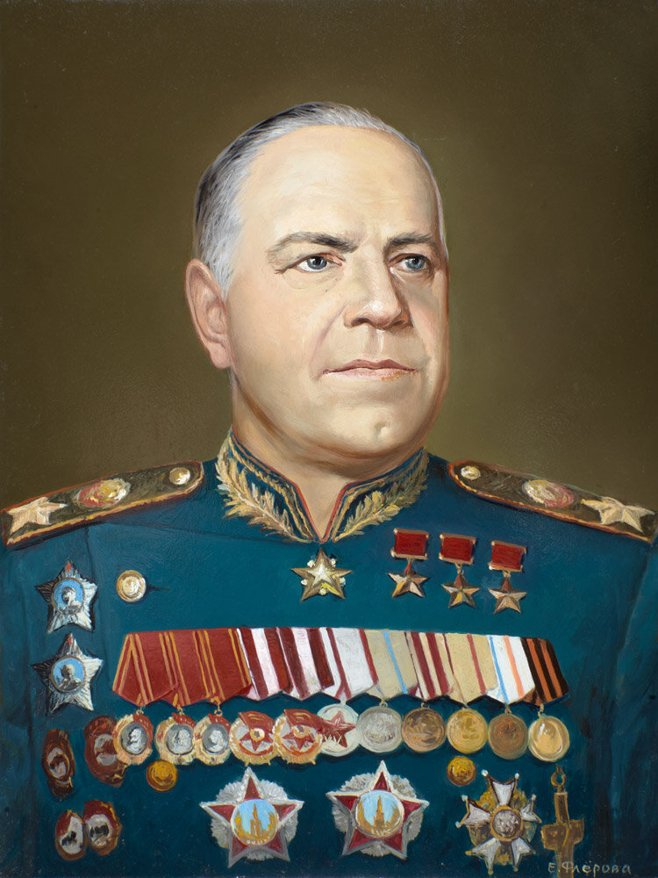 |  | Vasilevskiy Aleksandr  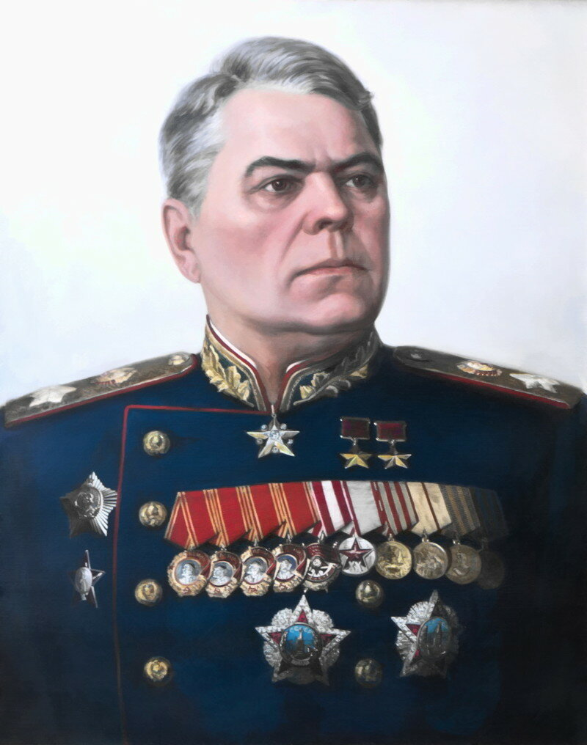  Mikhailovich
Koniev Ivan  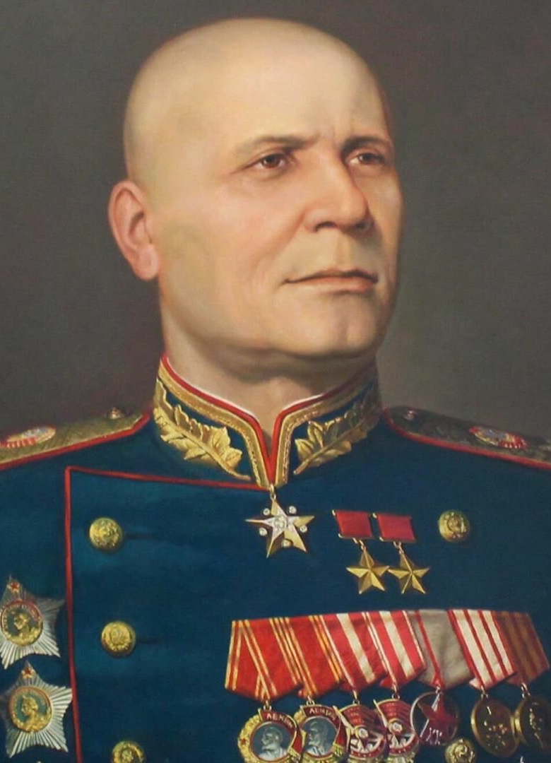  Stepanovich |  | Govorov Leonid  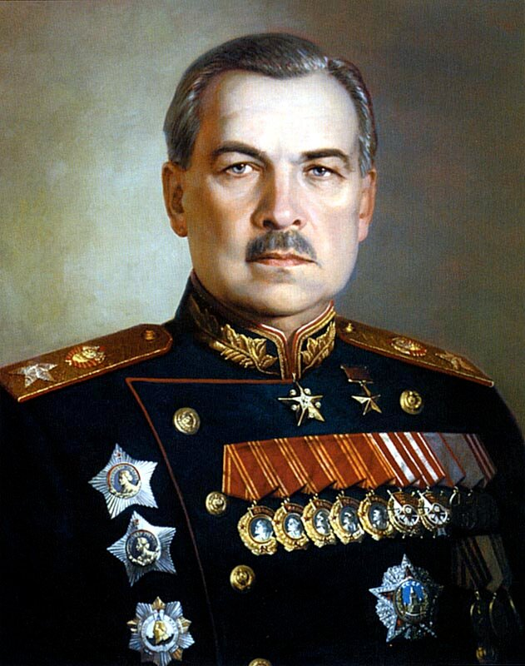  Aleksandrovich
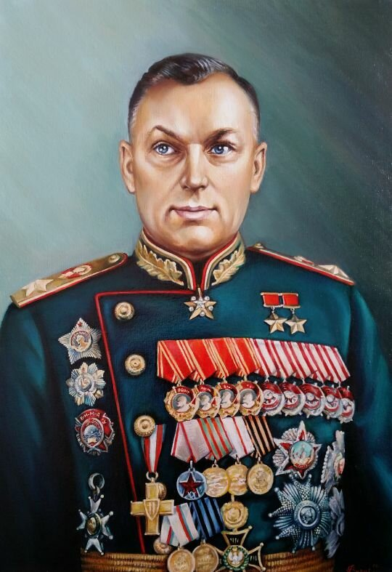  Rokossovsky Konstantin Konstantinovich |  | 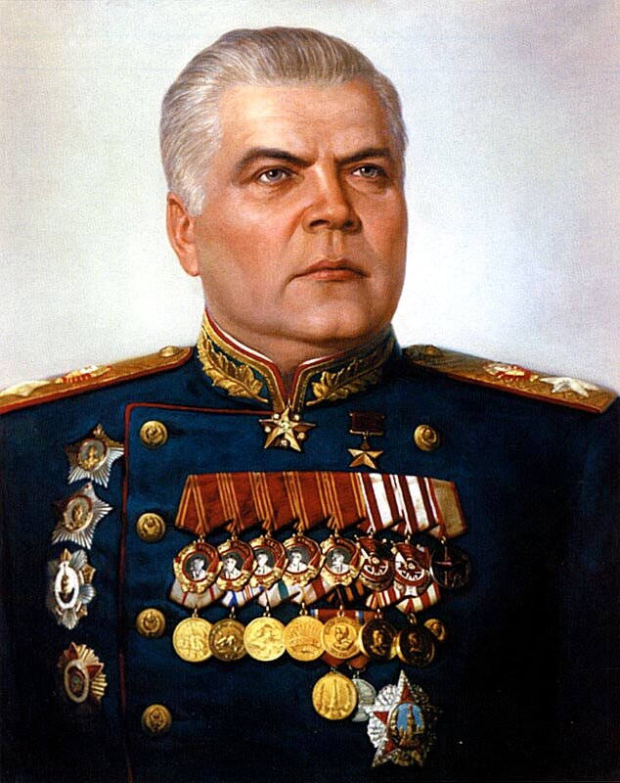  Malinovsky Rodion Yakovlevich

1 | The Hall immortalizes almost 27 million Soviet ___________________ who perished defending our Motherland in the years of the Great Patriotic War 1941–1945. | PERSON
2 | The sculptural composition in the Hall is named “Sorrow”. The image of the woman symbolizes all the mothers, ___________________, sisters and daughters | WIFE
3 | mourning for their husbands, brothers and sons ___________________ in the war. | KILL
4 | The sculptures ___________________ from Koyelga white marble mined in the Urals, Chelyabinsk region. The author of this piece of art is the sculptor, Hero of Socialist Labor People’s Artist of the USSR, L.E. Kerbel. | CARVE
5 | The showcases exhibit the “Books of Memory” with the names of soldiers who perished fighting for the Motherland, ___________________ in hospitals, | DIE
6 | went missing, as well as those who lost ___________________ lives in captivity during the war. | THEY
7 | Under the ceiling there are 2,600,000 bronze pendants with crystal “tears” ___________________ sorrow for the perished. | SYMBOLIZE

№ 3. Look through the collection of weapons in the images. Find them in the museum exhibition and write their names in English.

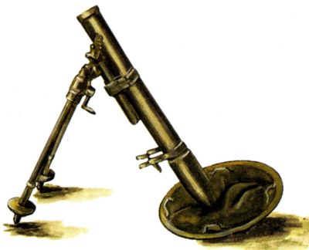 | _____________________________________
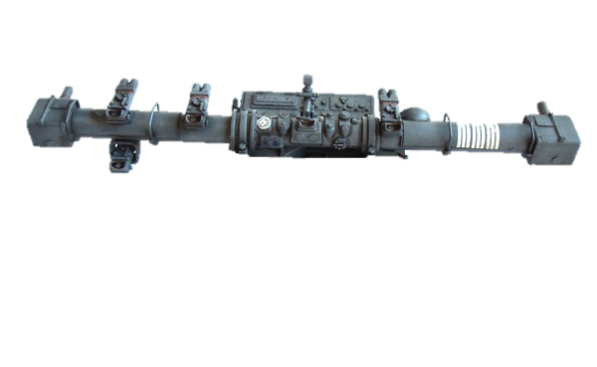 | _____________________________________
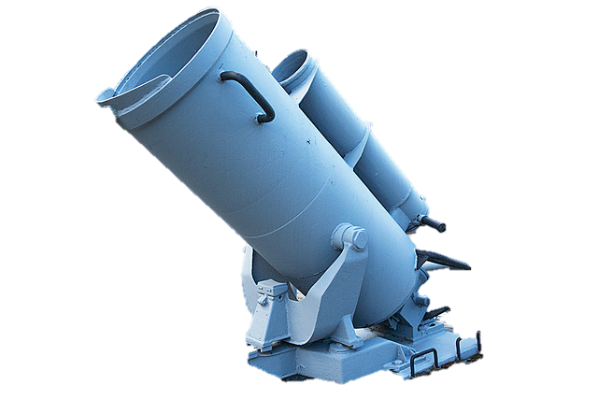 | _____________________________________
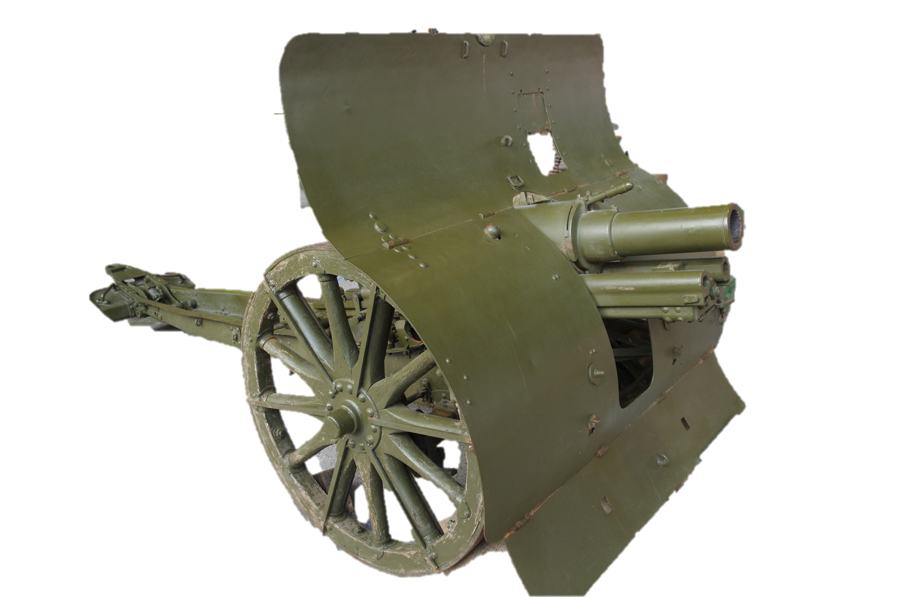 | _____________________________________
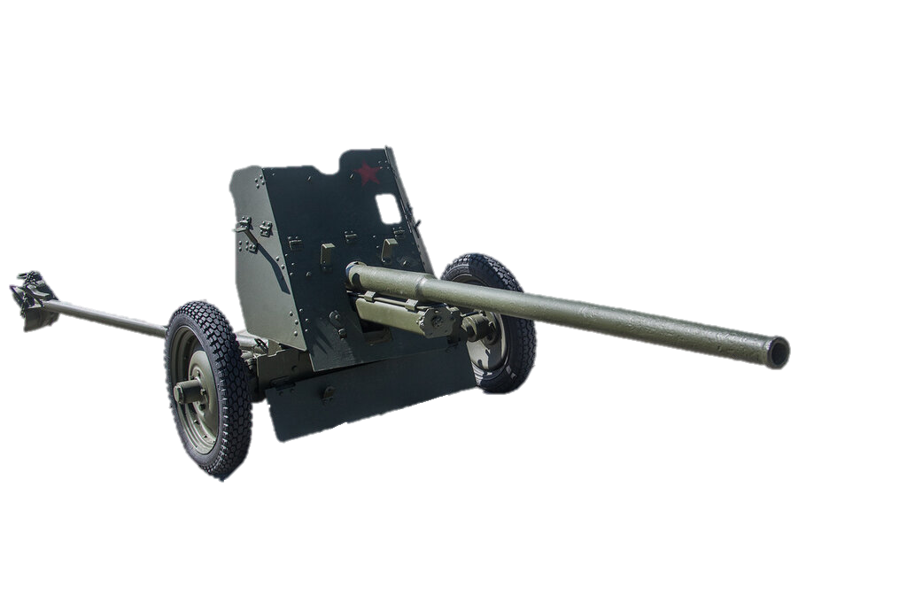 | ____________________________________

Зал Исторической Правды (The Hall of Historical Truth)

№ 4. In 2018 the president of Russia, Vladimir Putin, sent greetings to the participants and guests of the opening ceremony for the Hall of Historical Truth at the Victory Museum.

Read the text “Feat of the Army”. Use the word at the end of each line to form a new word that fits into the gap.

1 | “The country must have its heroes, and people must know them. These have to be a guiding ___________________, | REFER
2 | an example through which today’s ___________________ could be brought up and raise their children.” Vladimir Vladimirovich Putin | GENERATE
3 | The “Feat of the ___________________” exhibition of the Victory Museum is dedicated to all people who toiled for the future victory shoulder to shoulder during | ARM
4 | the four ___________________ years and spared no effort on the frontline as well as in the rear. | WAR
5 | ___________________ and soldiers defending their military positions to the last bullet, partisans fighting the enemy in occupied territories, doctors and nurses saving the wounded, all who took up arms… | COMMAND
6 | Each of them ___________________ and all of them together were bringing the Great Victory closer. | SEPARATE

№ 5. Look through the poster “The Red Army Liberation Mission” and compare the losses of the Red Army during the liberation of several European and Asian countries.

Fill in the gaps with the words and numbers from the box to complete the description of the chart.

China, Czechoslovakia, Korea, Norway, Poland, 691, 26000, 140000
Looking at the figures, we can see that the largest number of people, 600,000, were killed defending _______________ followed by Hungary with _______________ and _______________ with 139,000. The lowest number of casualties, _______________, occurred during the liberation of _______________. _______________ witnessed almost the same number of casualties as Yugoslavia.
The battles for _______________ and Austria took as many as 3,500 and _______________ lives, respectively.

Диорама «Курская битва» (The “Battle of Kursk” Diorama)

№ 6. Group 1. Describe the pictures given. Remember to depict the action and location as well as the foreground and the background. You have 2 minutes to prepare.
Group 2. Think about the following features and find the pictures connected with them:
1) different types of troops contributing to defeating the enemy; emphasise their importance in winning the war;
2) the hardships of the civilian population during the war;
3) the cruelty of the war;
4) the heroes of the war;
5) the officers in charge;
6) the partisan detachments;
Students of the first group describe the pictures; Students of the second group match the pictures to their features and comment on them.

